M30无磁产品页翻译

LXSY-15~25 系列阀控一体式远传水表是用于计量流经自来水管道的水体积总量的测量仪表，适用于小型工业用水和家 庭用水，具有计量精度高、始动流量小、计数机构防污性好、抄读方便、外形美观、安全卫生、寿命长等特点。该水表用于计量流经管道内的饮用水流总量，用户可在该水表指示器上直观读取流过水表水的体积。

简介：

1. 远传模块和基表分体式设计，安装方便，维护成本低。IP68防护等级，适应各种复杂环境。
2. 无磁脉冲，微功耗设计，抗磁干扰。
3. 可采用 M-BUS\RS485 总线方式通讯，或采用 NB-IoT、LoRa 或 LoRaWan 无线方式通讯，实现水表使用水量的远程直读。
4. 阀控式水表可通过管理软件远程控制水表阀门的开、关，使得远程抄表及控制变得更便捷、可靠，节约人力、提高效率。
5. 本系列水表，通信规约遵循 CJ/T188 或 DL/T645 的要求，也可根据客户需求定制通信协议。
6. 球形宝石轴承及优化的齿轮配合保证表计可对不同的流态进行长期精确测量:
7. 干式\湿式基表、铁壳\铜壳\塑壳\不锈钢外壳多种材质可选择;外置天线可选;

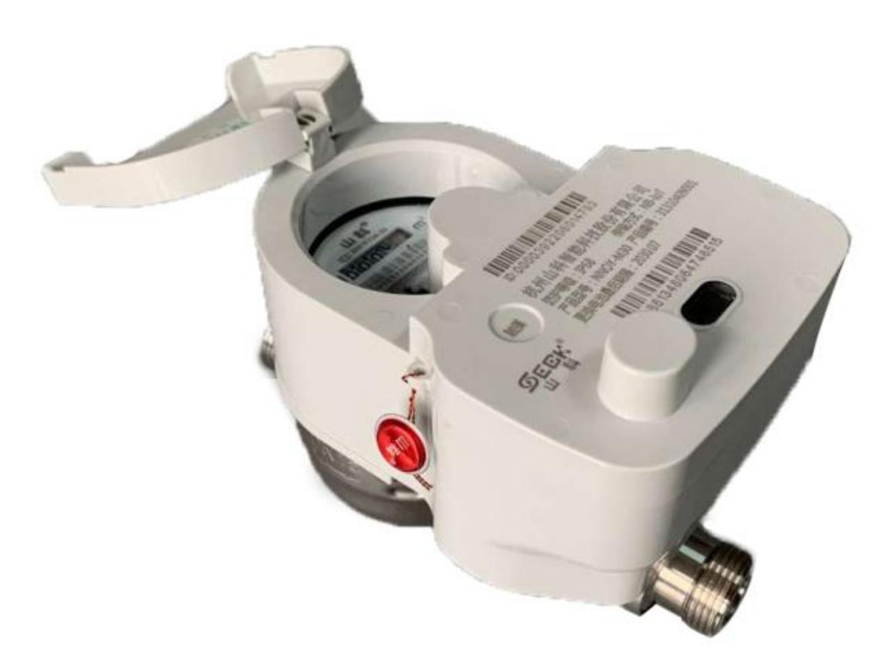The LXSY-15~25 series valve-controlled integrated remote-transmission water meter is a device for measuring the total water volume flowing through water supply pipes. It's designed for small-scale industrial and domestic water use. It offers high measurement accuracy, a low start-up flow rate, resistance to contamination of its counting mechanism, convenient reading, an attractive appearance, safety, hygiene, and a long service life. This water meter measures the total volume of potable water flowing through pipes, allowing users to directly read the water volume on its indicator.

1.Using remote module and separate base design; easy installation; low maintenance costs

2.Magnetic induction data collection; low-power design; anti-magnetic interference.

3.M-BUS/RS485 bus communication or NB-IoT/LoRa wireless communication for remote water meter reading.

4.IP68 protection rating; suitable for various complex environments.

5.Valve - controlled water meters enable remote valve operation via management software, making meter reading and control more convenient, reliable, labor - saving, and efficient.

6.These water meters comply with CJ/T188 or DL/T645 communication protocols and support custom protocols as per customer needs.

7.Spherical jewel bearings and optimized gear design ensure long - term accurate measurement of varied flow states.

8.Available in dry/wet base meters and iron/copper/plastic/stainless steel casings; optional external antenna.

